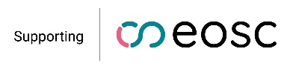
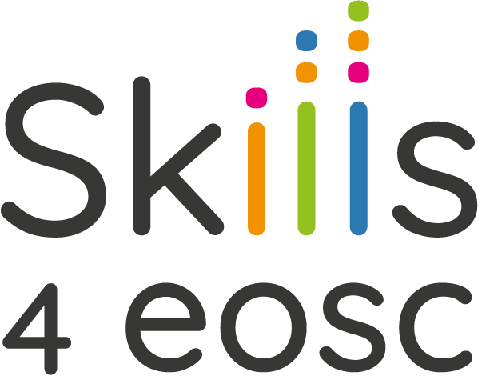

Coordination network for the Skills4EOSC Competence Centres and Support Centres

Memorandum of Understanding (MoU) Template

This Memorandum of Understanding (hereinafter referred to as “MoU”) is entered into between the Skills4EOSC Competence Centres Network (CCNet) and [Competence Centre Name] (hereinafter referred to as "the Parties"), with the purpose of formalizing their intention to collaborate and foster cooperation in Open Science.

Introduction of the Parties
The Skills4EOSC Competence Centre Network (CCNet) is a collaborative network of national, regional, and thematic Competence Centres across Europe and beyond, supporting Open Science practices. Established under the EU-funded Horizon Europe Skills4EOSC project, CCNet connects organizations and experts in Open Science, FAIR data principles, and digital research management. The network promotes knowledge exchange, provides community-specific support, and ensures the sustainability and evolution of Skills4EOSC project outputs through contributions of its members to the Editorial Board and specialized Working Groups.
[Competence Centre Name] is a [brief description of the Competence Centre's mission, activities, and expertise], committed to advancing Open Science and contributing to the EOSC ecosystem in [Country/Region/Theme].

Objectives and Scope of Cooperation
This MoU signifies the intention of the Parties to establish a collaborative relationship in the following areas for their mutual benefit:
- Networking and Peer-Learning: Facilitating collaboration, knowledge exchange, and best practice sharing among Competence Centres.
- Training and Capacity Building: Developing and delivering targeted training programs and learning paths in Open Science, FAIR data principles, and digital research management.
- Support for Research Organizations: Providing assistance to research organizations lacking national infrastructure or expertise in Open Science.
- Development and Evolution of Key Outputs: Contributing to the continuous development, maintenance, and adoption of Skills4EOSC methodologies, including participation in the Editorial Board and Working Groups.
- Partnerships and Advocacy: Promoting research integrity, supporting advocacy efforts, and identifying EU funding opportunities.
- Collaboration with European and Global Organizations: Building strategic partnerships with other entities committed to Open Science and EOSC.
- Publications and Position Papers: Engaging in joint publications and statements to influence Open Science policies.
- Sustainability of Results: Ensuring the ongoing impact of the Skills4EOSC project by maintaining and further developing its results.

Governance and Representation
The Skills4EOSC CCNet operates through a collaborative governance model comprising:
- General Assembly: Composed of two representatives from each Competence Centre, serving as the main decision-making body.
- Presidency: Led by a representative from a member Competence Centre, responsible for chairing the Network, acting as the primary point of contact, and ensuring effective coordination.
- Editorial Board: Overseeing the development, maintenance, and dissemination of Skills4EOSC outputs.
- Specialized Working Groups: Addressing specific challenges and initiatives within the Open Science landscape.
The Skills4EOSC Competence Centre Charter outlines the general criteria for joining CCNet. Upon signing this MoU, [Competence Centre Name] will nominate two representatives to participate in the General Assembly.

Administrative and Legal Considerations
- This MoU is not a legally binding document. It represents the Parties' good-faith intention to collaborate. This notwithstanding, the Parties jointly represent that they will apply any reasonable means and efforts towards fulfilling the provisions below.
- [Competence Centre Name] undertakes to contribute the necessary resources including time of their staff, necessary budgets for travel and subsistence in order to ensure the [Competence Centre Name] participation as a member, as well as representation of the community.
- In respect of any information or materials supplied by one Party to another under the CCNet, be it by granting access to electronic resources or otherwise (jointly referred to as ‘Access Rights’), no warranty or representation of any kind is made, given or implied as to the sufficiency or fitness for purpose nor as to the absence of any infringement of any proprietary rights of third parties. Therefore, the recipient Party shall in all cases be entirely and solely liable for the use to which it puts such information and materials. No Party granting Access Rights shall be liable in case of infringement of proprietary rights of a third party resulting from any other Party (or its entities under the same control) exercising its Access Rights.
- No Party shall be responsible to any other Party for any indirect or consequential loss or similar damage such as, but not limited to, loss of profit, loss of revenue, or loss of contracts. A Party’s liability shall not be limited under the foregoing paragraphs to the extent such damage was caused by a wilful act or gross negligence or to the extent that such limitation is not permitted by law.
- Each Party shall be solely liable for any loss, damage, or injury to third parties resulting from the performance of the said Party’s obligations by it or on its behalf under this MoU or from its use of Results or Background.
- The Parties shall endeavour to settle any disputes amicably. If such a dispute cannot be resolved, the courts of Brussels shall have exclusive jurisdiction.
- The signatories of the two Parties will maintain regular contact to discuss any managerial matters related to the cooperation described in this MoU or to be integrated into it.
- Each Party will maintain full responsibility for its own activities.

Nomination of Representatives

[Competence Centre Name] hereby nominates the following two representatives to participate in the General Assembly of the Skills4EOSC Competence Centres Network:
- [Full Name of Representative 1], [Role/Position/Contact Email]
- [Full Name of Representative 2], [Role/Position/Contact Email]

These representatives shall serve as the official delegates of [Competence Centre Name] in all matters pertaining to the General Assembly.

Duration
This MoU shall enter into force on the date of signature and will remain valid for four years, unless otherwise agreed upon by the Parties.

Signatures
For the Skills4EOSC Competence Centres Network (CCNet)
[Name and Title]
Representative of the Presidency of the Network
Email: [Contact Email]
Address: [Institution Address]
Website: [Institution Website]
Signature: ____________________
Date: ____________________
For the Competence Centre Name
[Name and Title]
Email: [Contact Email]
Address: [Institution Address]
Website: [Institution Website]
Signature: ____________________
Date: ____________________

See at https://zenodo.org/records/10048176

